Group symbol: 2
Team: 1

Project title: ListItUp

Team members (filled by PM, Team Leader):
No | Name | Surname | Student ID | Role
1 | Carmelo | Romero Pérez | 293936 | PM, Team Leader
2 | Álvaro | Puebla Ruisánchez | 293867 | Team member
3 | Carmen | Gutiérrez Sánchez | 293906 | Team member
4 | David | Sosa Domínguez | 293885 | Team member
5 | Diego | García Agrelo | 293939 | Team member
6 | Miryam | Merchán León | 293907 | Team member

- Requirements specification (S2)
  - Functional Requirements Specification
In this section, provide the table for functional requirements, including symbol, type (e.g. business logic, user interface, data exchange, etc.) description, significance (MoSCoW) and source (Stakeholder).
The requirements are structured around five domains: user account management, list and item management, social interaction, content discovery, and platform administration. Must-have requirements constitute the minimum viable set for the pilot release; Should-have requirements extend the experience without blocking the first release.

MVP Functional Requirements: core features (Must = critical, Should/Could = less critical)
Symbol | Type | Description | Significance | Source
FR1 | User Interface / Authentication | Social Login: Users register and log in via Google or GitHub using OAuth 2.0. No platform-specific password is required. | Must | E1 - Casual Users  E2 - Verified Creators
FR2 | Business Logic / User Management | User Profile: Each user has an editable public profile with a username, biography, and profile picture. Verified creators additionally display a badge. | Must | E1 - Casual Users  E2 - Verified Creators
FR3 | Business Logic | Create a List: Authenticated users can create and publish a curated list with a title, description, cover photo, and public/private visibility. | Must | E1 - Casual Users  E2 - Verified Creators
FR4 | Business Logic / Data Management | Manage Items: Users can add, edit, reorder, and delete items within a list. Each item supports a title, short description, external URL, and optional photo. | Must | E1 - Casual Users  E2 - Verified Creators
FR5 | User Interface / Search | Discovery and Search: The platform offers a category-based feed of public lists and a keyword search filterable by category and sortable by relevance or recency. | Must | E1 - Casual Users  E2 - Verified Creators
FR6 | Business Logic / Social Interaction | Social Interactions: Authenticated users can follow others, like lists, post comments, and save lists to a personal collection. | Must | E1 - Casual Users  E2 - Verified Creators
FR7 | Business Logic / Moderation | Reporting and Moderation: Users can report lists, items, or comments. Administrators can review reports and delete any content from a dedicated panel. | Must | E1 - Casual Users  E3 - Administrators
FR8 | Data Exchange / Notifications | Notifications: The system sends in-app notifications for likes, comments, and new posts from followed creators. Key events also trigger email notifications via a third-party provider. | Should | E1 - Casual Users  E2 - Verified Creators  E4 - API Providers
FR9 | User Interface / Analytics | Creator Analytics: Verified creators have access to a private dashboard showing per-list statistics: views, saves, likes, and link clicks, updated daily. | Should | E2 - Verified Creators

  - Non-Functional Requirements
In this section provide the table for non-functional requirements that includes symbol, type (e.g., efficiency, standards, constraints, etc.), description, significance (MoSCoW) for the project, source (Stakeholder). Each requirement should also have specified a verification method - a description of a confirmation method whether a requirement has been fulfilled or not in the most measurable and objective way.
Key non-functional requirements derive from the project’s technological, legal and organizational context. These include security (campus SSO, encryption), performance and scalability, accessibility and audit compliance, and deployment constraints. Metrics and verification methods are specified to ensure measurable quality.

Symbol | Type | Description | Significance | Source | Verification method
NF1 | Performance / Efficiency | Page Load Time: Primary pages must fully render within 3 seconds on a standard broadband connection, measured as Time to Interactive (TTI). | Must | E1 - Casual Users  E2 - Verified Creators | Verification: Run Lighthouse on the three core pages from a cold cache; all TTI values must be below 3 seconds.
NF2 | Reliability / Availability | System Uptime: The platform must maintain at least 99.5% uptime throughout the pilot period. | Must | E1 - Casual Users  E3 - Administrators | Verification: Monitor uptime via UptimeRobot with 1-minute polling; compute the monthly ratio at the end of the pilot and confirm it meets or exceeds 99.5%.
NF3 | Security / Legal | HTTPS and GDPR Compliance: All communication must be encrypted via TLS 1.2 or higher. The platform must support user rights under GDPR/RODO and display a cookie-consent banner on first visit. | Must | E1 - Casual Users Legal - GDPR | Verification: Manually confirm that account deletion removes all user data, that the cookie banner appears before non-essential cookies are set, and that users can export their personal data.
NF4 | Usability / Compatibility | Responsiveness and Usability: The UI must work across the two most recent versions of Chrome, Firefox, and Safari on desktop and mobile. At least 80% of pilot users must complete the create-and-publish-list task without assistance. | Must | E1 - Casual Users  E2 - Verified Creators | Verification: Run a manual test suite across all target browsers and viewports. Conduct a usability session with at least 5 first-time users and record the task completion rate (target ≥80%).

  - Use Case Diagram
You should prepare the use case diagram in UML 2.5 depicting the roles of stakeholders who are users of the project. It should also present the high-level concept of system usage divided into modules. Use case diagram should not cover common business logic (e.g. registration and logging in, CRUD operations).
The use case diagram below follows UML 2.5 notation and presents the high-level concept of system usage divided into four modules. Common infrastructure concerns — user registration, login, and standard CRUD operations — are excluded, as these are addressed by the OAuth 2.0 integration (FR1) and the domain model defined in the S1 report.

Actor | Description
Casual User (E1) | A registered standard user who browses, creates, and interacts with content. Primary actor across all four modules.
Verified Creator (E2) | Extends Casual User with exclusive access to the Creator Analytics Dashboard and the ability to pin lists to their profile. Modelled using <<extend>> relationships.
App Administrator (E3) | A privileged operator responsible for platform moderation. Interacts exclusively with the Administration module.
Third-Party API Provider (E4) | An external system actor representing services consumed by the platform: OAuth provider, Open Graph metadata service, image host, and transactional email provider.

Module | Use Cases | Actors
List Management | UC1: Create and Publish List UC2: Add / Edit / Reorder / Delete Items UC3: Set List Visibility UC4: Pin List to Profile <<extend>> UC5: Enrich Item Link via Open Graph <<include>> | UC1-UC3: Casual User, Verified Creator UC4: Verified Creator only UC5: Third-Party API Provider (system)
Social & Discovery | UC6: Browse Category Feed UC7: Search Lists and Items by Keyword UC8: Follow / Unfollow a User UC9: Like a List UC10: Comment on a List UC11: Save List to Personal Collection UC12: View Creator Analytics Dashboard <<extend>> | UC6-UC11: Casual User, Verified Creator UC12: Verified Creator only
Notifications | UC13: Receive In-App Notification UC14: Receive Email Notification <<include>> | UC13: Casual User, Verified Creator UC14: Third-Party API Provider (system)
Administration | UC15: Review Content Report Queue UC16: Delete List / Item / Comment UC17: Submit Content Report (initiation) | UC15-UC16: App Administrator UC17: Casual User, Verified Creator (initiates); App Administrator (processes)

List Management:
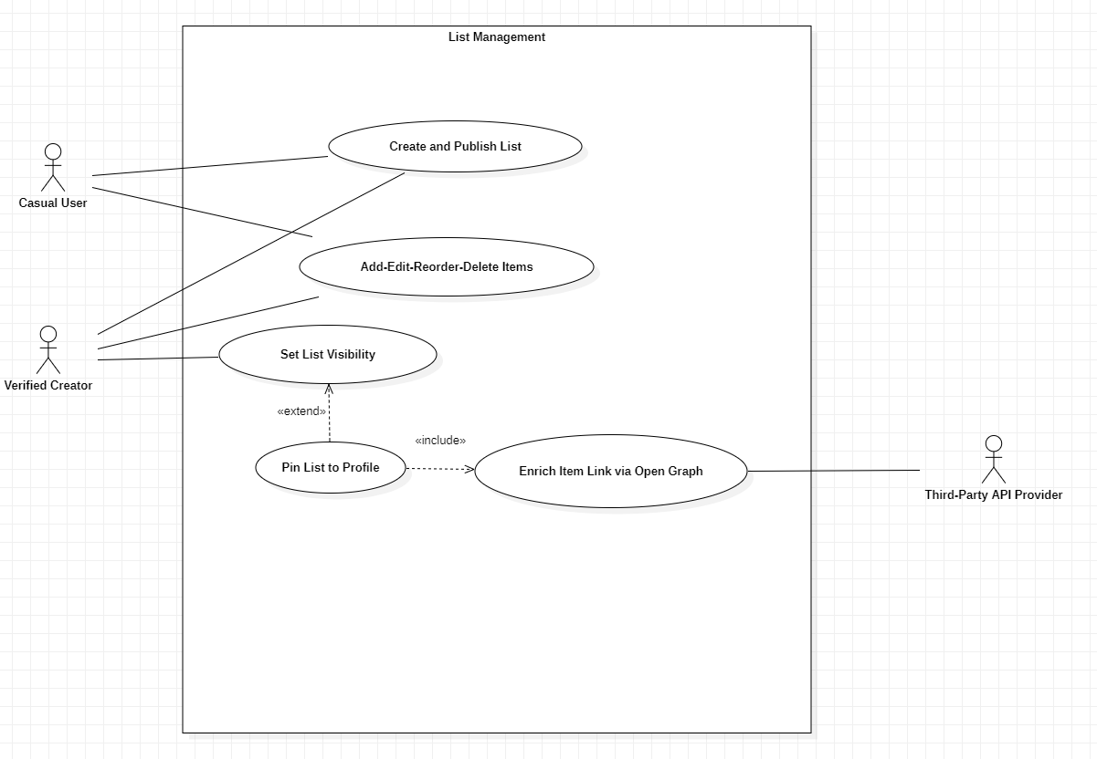

Social & Discovery:
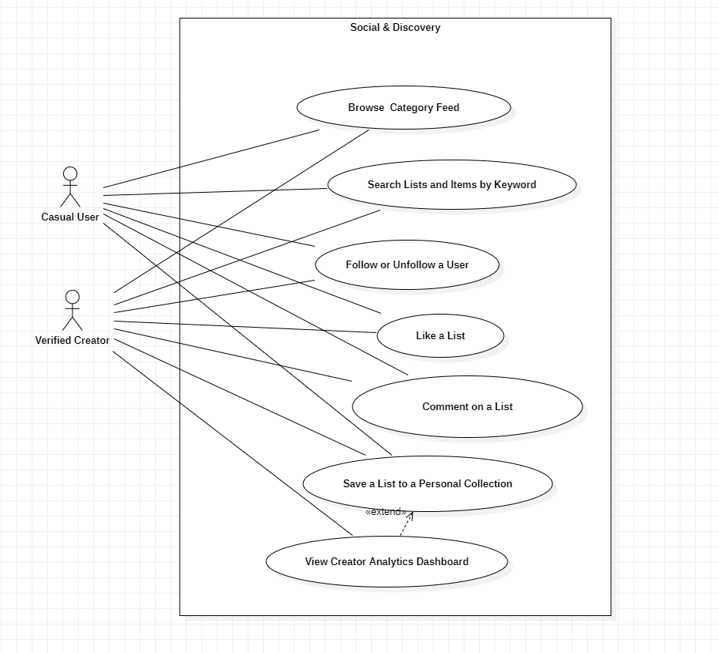

Notifications:
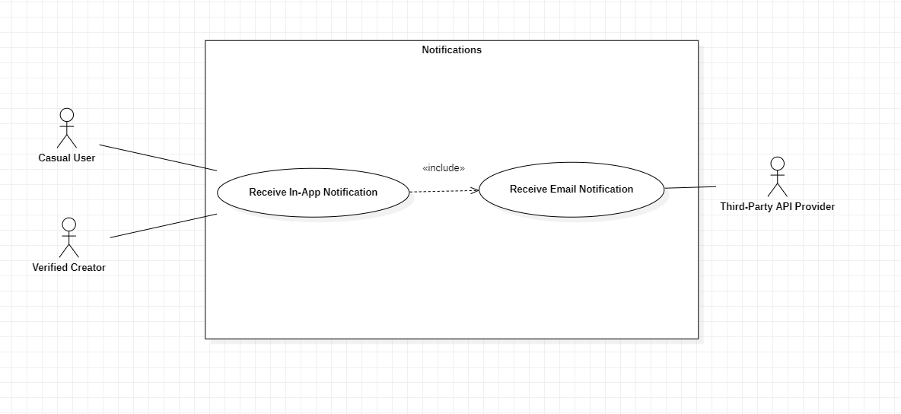

Administration:
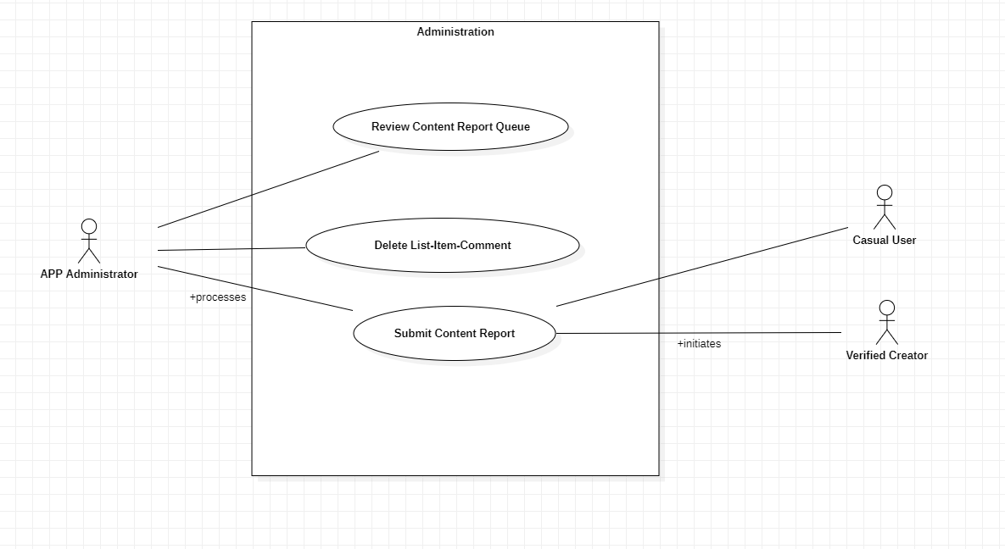

NOTE FOR SUBMISSION: Insert the UML 2.5 Use Case Diagram image here, produced using draw.io or equivalent tooling, stored in the project repository under /docs/diagrams/S2_use_case_diagram.png. The diagram must depict the four actors on the margins, the four system-boundary rectangles labelled as in the table above, and the use case ellipses with <<include>> and <<extend>> dependency arrows as specified.

